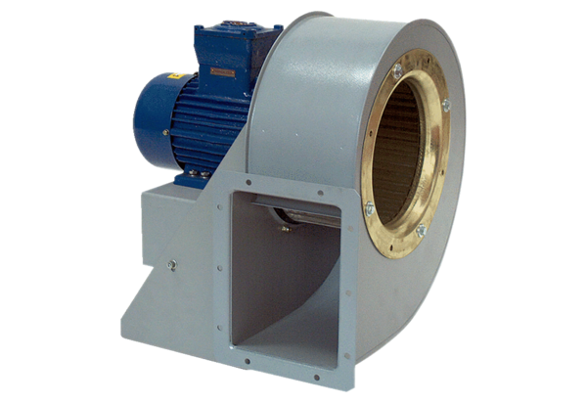Centrifugal blower GRM HD 35/4-2 ExPacking unit: 1 pieceRange: C
Article number: 0073.0410Manufacturer: MAICO

