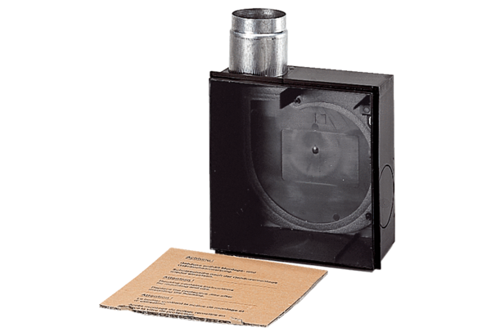Recessed-mounted housing ER - UPDPacking unit: 1 pieceRange: B
Article number: 0093.0972Manufacturer: MAICO

