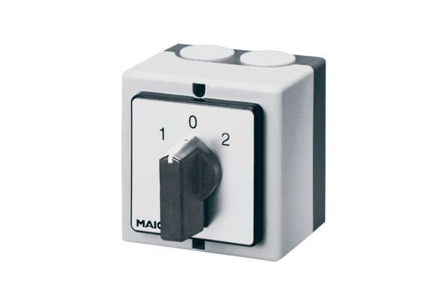Pole-changing switch P 2Packing unit: 1 pieceRange: C
Article number: 0157.0106Manufacturer: MAICO

