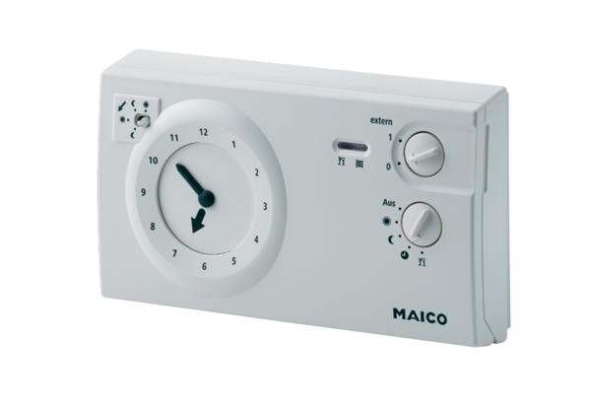Room air control RLS 2 FPacking unit: 1 pieceRange: K
Article number: 0157.0806Manufacturer: MAICO

