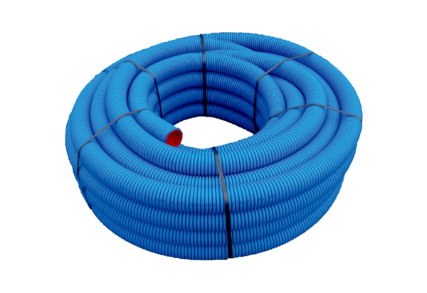Flexible duct MA-FR63Range: K
Article number: 0152.0090Manufacturer: MAICO

