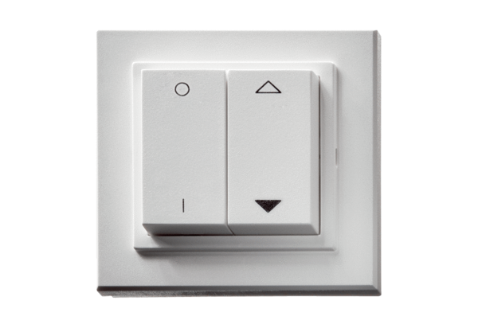Radio switch DS RCPacking unit: 1 pieceRange: C
Article number: 0157.0832Manufacturer: MAICO

