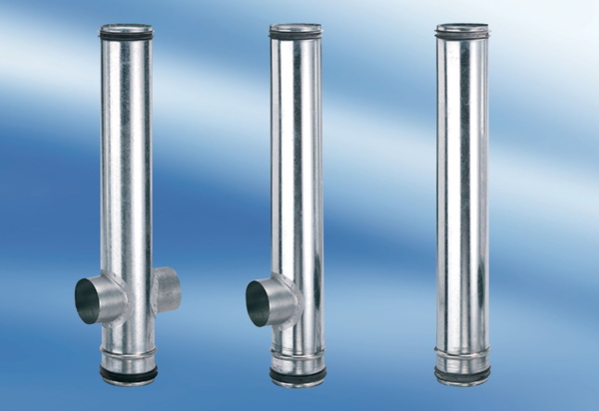BA 140/80-2Packing unit: 1 pieceRange: B
Article number: 0093.0051Manufacturer: MAICO

