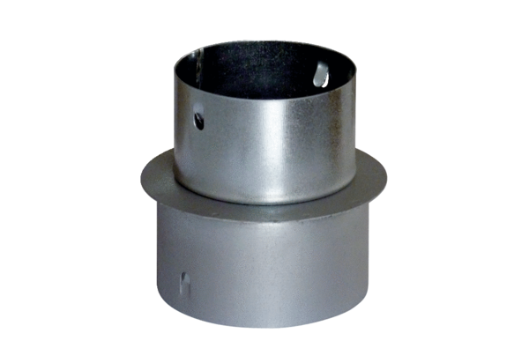Reducer MF-RZ90/75Packing unit: 1 pieceRange: K
Article number: 0018.0073Manufacturer: MAICO

