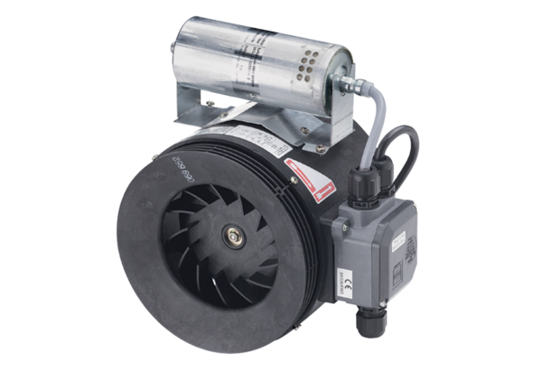Semi-centrifugal duct fan ERM 18 Ex t/60 HzPacking unit: 1 pieceRange: C
Article number: 0080.0376Manufacturer: MAICO

