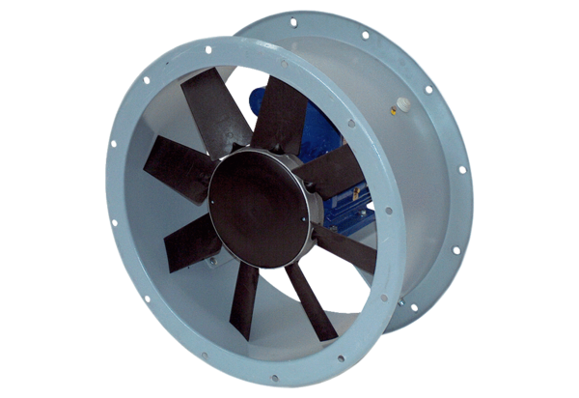Axial duct fan DAR 80/6-1 ExPacking unit: 1 pieceRange: C
Article number: 0073.0357Manufacturer: MAICO

