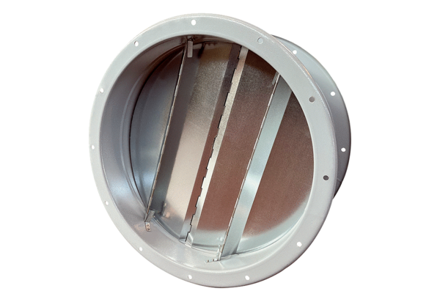Duct shutter VKRI R 71Packing unit: 1 pieceRange: C
Article number: 0073.0089Manufacturer: MAICO

