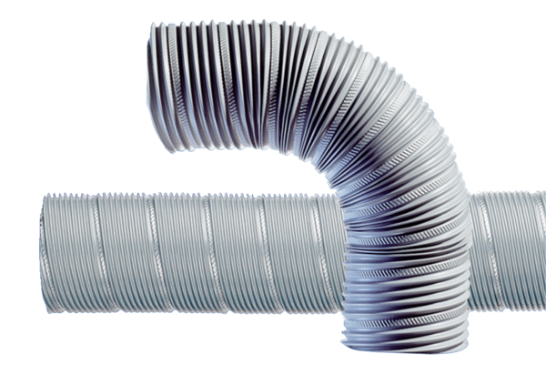Flexible steel duct SFR 80Packing unit: 1 pieceRange: B
Article number: 0055.0072Manufacturer: MAICO

