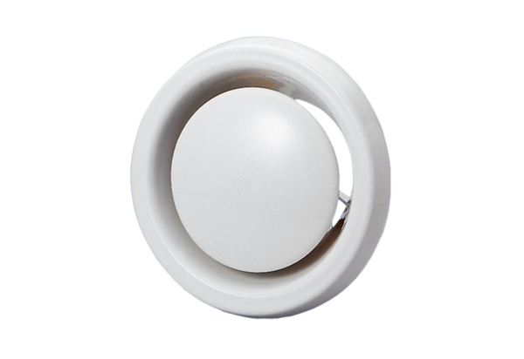Disk valve, fire protection WBV 10Packing unit: 1 pieceRange: B
Article number: 0151.0275Manufacturer: MAICO

