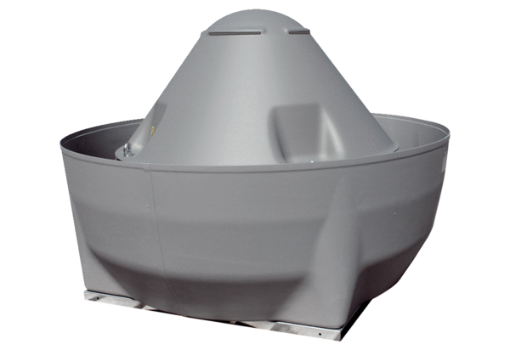Centrifugal roof fan DRD V 90/6 ExPacking unit: 1 pieceRange: C
Article number: 0073.0555Manufacturer: MAICO

