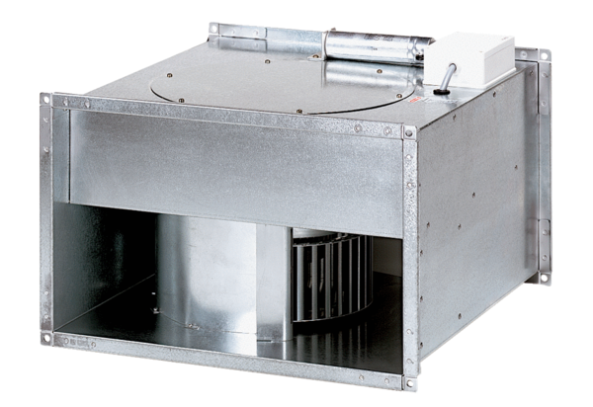Channel fan EPK 28/6 BPacking unit: 1 pieceRange: D
Article number: 0086.0654Manufacturer: MAICO

