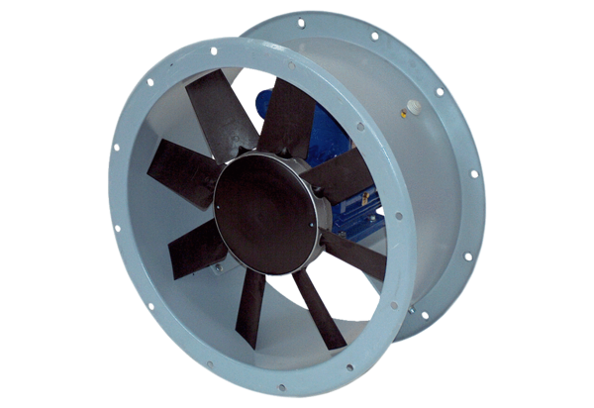Axial duct fan DAR 90/8-3 ExPacking unit: 1 pieceRange: C
Article number: 0073.0371Manufacturer: MAICO

