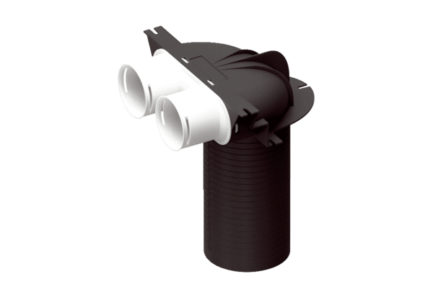Deflection piece MA-U2-75Packing unit: 1 pieceRange: K
Article number: 0059.2117Manufacturer: MAICO

