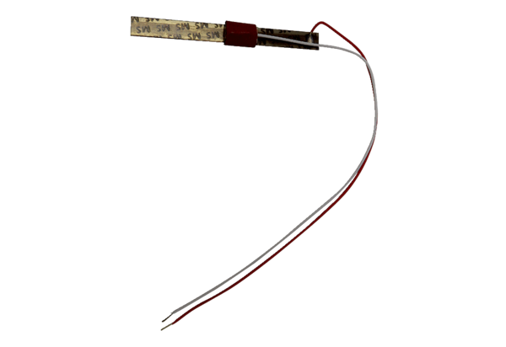Thermostatic bimetal strip TB ECA 150 KRange: A
Article number: E180.0913.9400Manufacturer: MAICO

