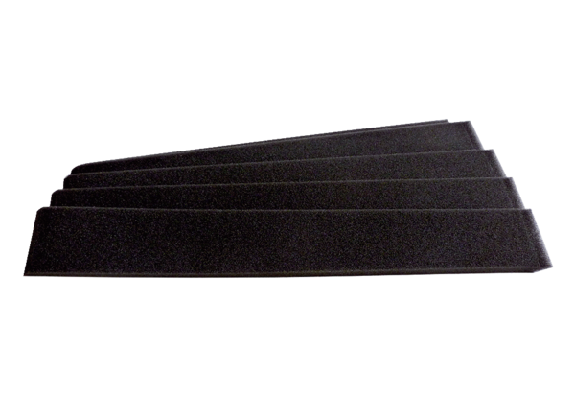Replacement heat exchanger rings WRF 20Packing unit: 5 piecesRange: D
Article number: 0093.0347Manufacturer: MAICO

