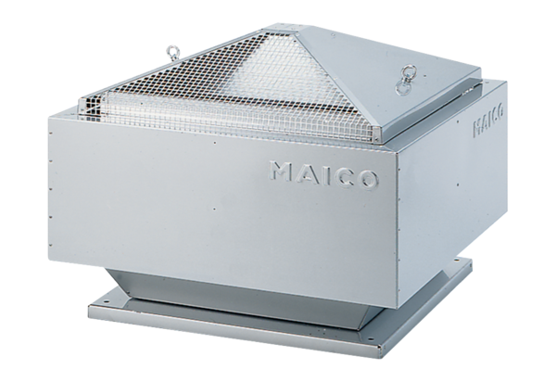Centrifugal roof fan DRD 40/6 BPacking unit: 1 pieceRange: C
Article number: 0087.0109Manufacturer: MAICO

