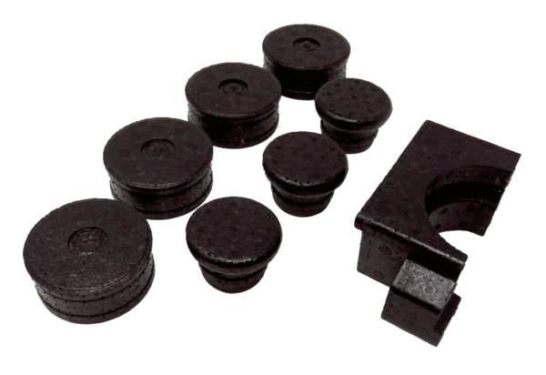End plug WS 75 SPacking unit: 8 itemsRange: K
Article number: 0058.0504Manufacturer: MAICO

