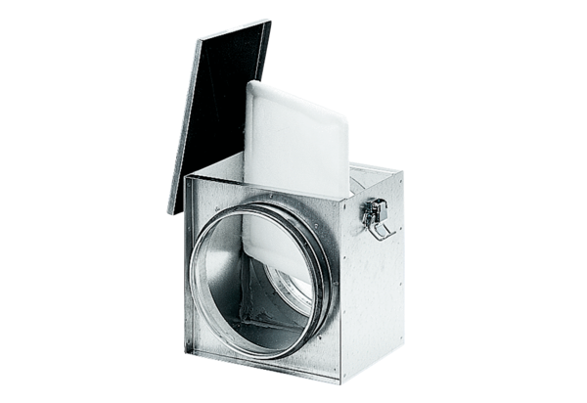Air filter TFE 25-4Packing unit: 1 pieceRange: C
Article number: 0149.0079Manufacturer: MAICO

