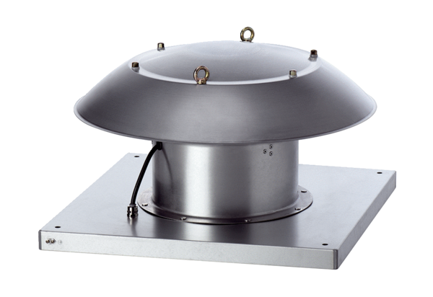Axial roof fan DZD 30/2 B Ex ePacking unit: 1 pieceRange: C
Article number: 0087.0800Manufacturer: MAICO

