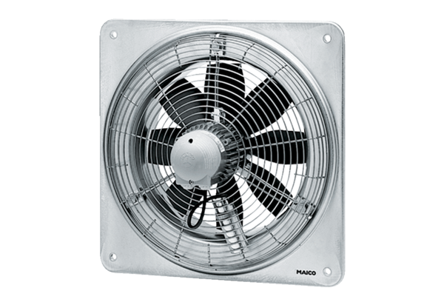Axial wall fan DZQ 25/4 DPacking unit: 1 pieceRange: C
Article number: 0083.0490Manufacturer: MAICO

