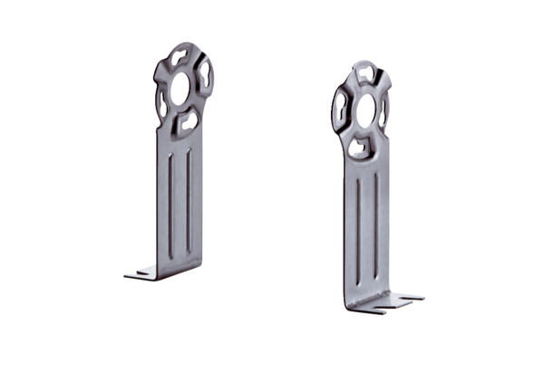Mounting foot FUR 16S/20/25Packing unit: 1 pieceRange: C
Article number: 0036.0088Manufacturer: MAICO

