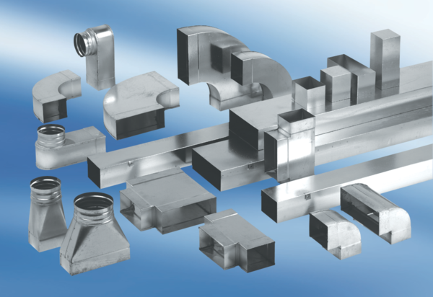45° branch, horizontal AZ45H55/110/55/110Packing unit: 1 pieceRange: K
Article number: 0055.0733Manufacturer: MAICO

