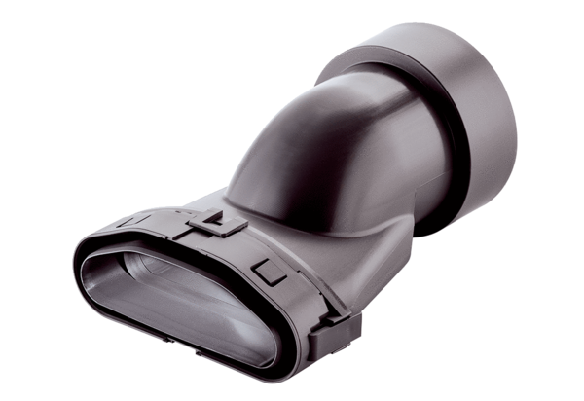Transition piece flat/round FFS-Ü90/75Packing unit: 1 pieceRange: K
Article number: 0055.0887Manufacturer: MAICO

