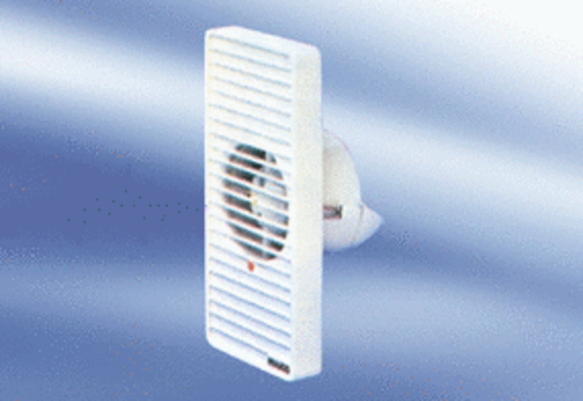Small room fan ECA 9-2 VZPacking unit: 1 pieceRange:
Article number: 080046Manufacturer: MAICO

