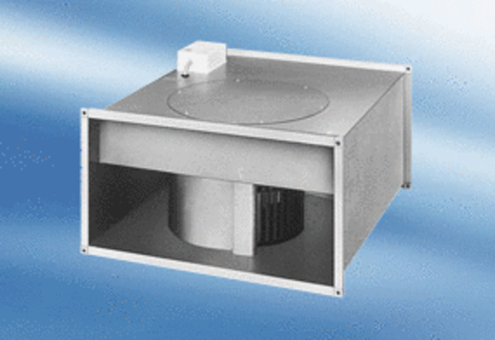Channel fan EPK 31/6 APacking unit: 1 pieceRange:
Article number: 0086.0616Manufacturer: MAICO

