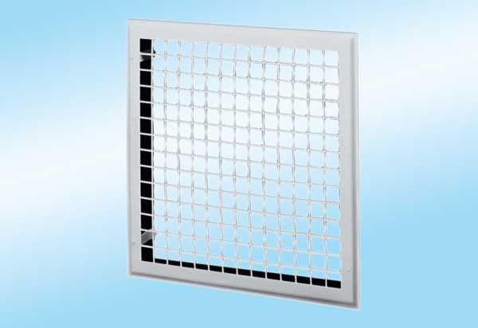Internal grille MLG 25Packing unit: 1 pieceRange: C
Article number: 0151.0062Manufacturer: MAICO

