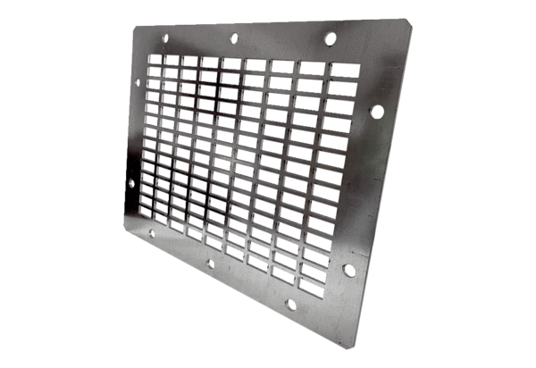Air outlet grille SGAI GR 25Packing unit: 1 pieceRange: C
Article number: 0073.0427Manufacturer: MAICO

