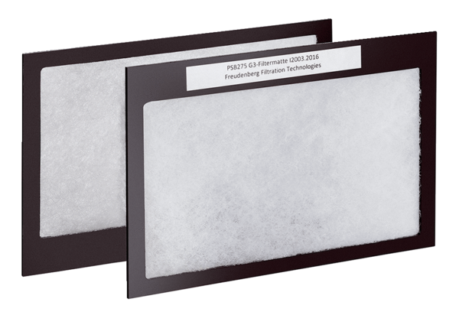Air filter, replacement Duo G3Packing unit: 2 piecesRange: K
Article number: 0093.0028Manufacturer: MAICO

