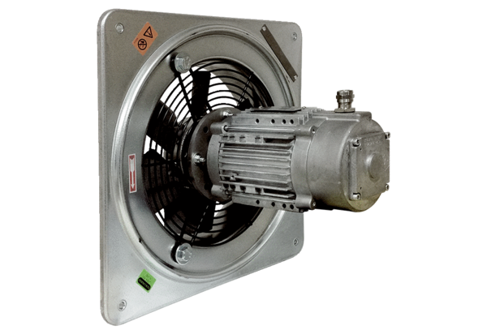Axial wall fan DAQ 71/4 ExPacking unit: 1 pieceRange: C
Article number: 0073.0337Manufacturer: MAICO

