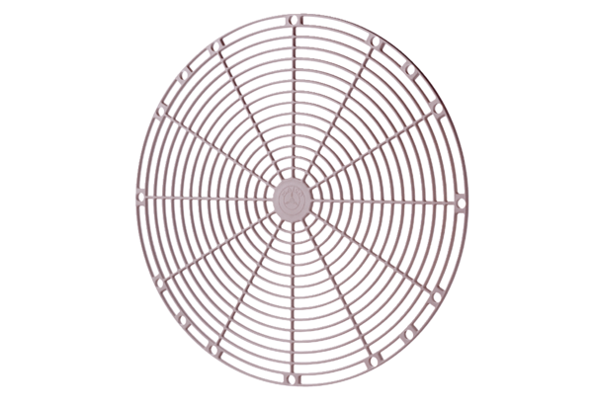Protective grille, synthetic material SGK 40Packing unit: 1 pieceRange: C
Article number: 0059.0165Manufacturer: MAICO

