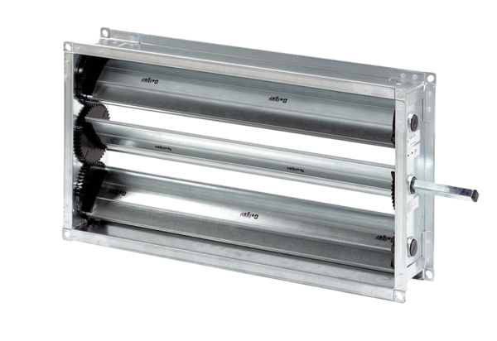Channel shutter RKP 22Packing unit: 1 pieceRange: D
Article number: 0151.0235Manufacturer: MAICO

