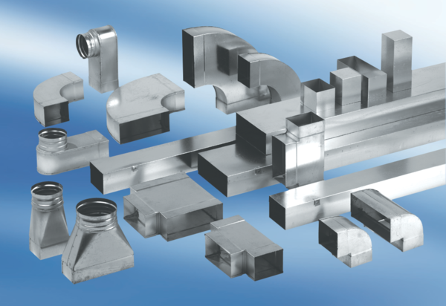90° angle elbow, right-sided asymmetrical WB90ARN80/200/100Packing unit: 1 pieceRange: K
Article number: 0055.0654Manufacturer: MAICO

