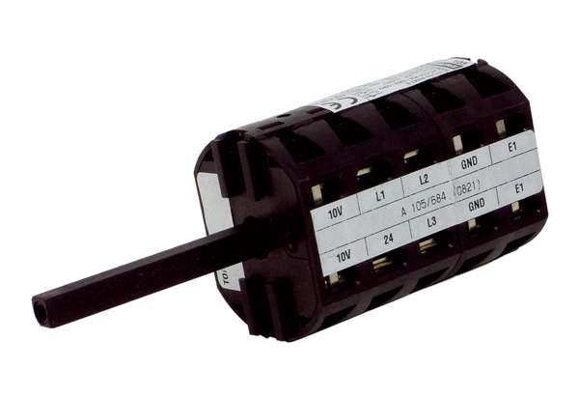Repair switch RS MDR35Packing unit: 1 pieceRange: E
Article number: E157.1634.0000Manufacturer: MAICO

