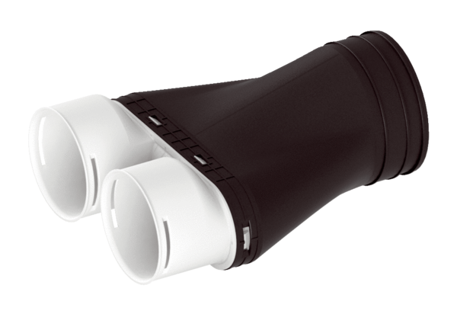Adapter MA-AD2-90Packing unit: 1 pieceRange: K
Article number: 0059.2122Manufacturer: MAICO

