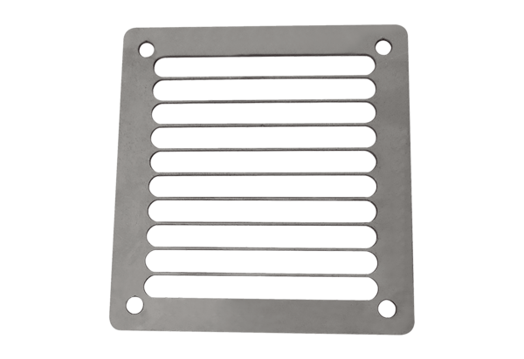Air outlet grille SGAI ES 10Packing unit: 1 pieceRange: C
Article number: 0073.0325Manufacturer: MAICO

