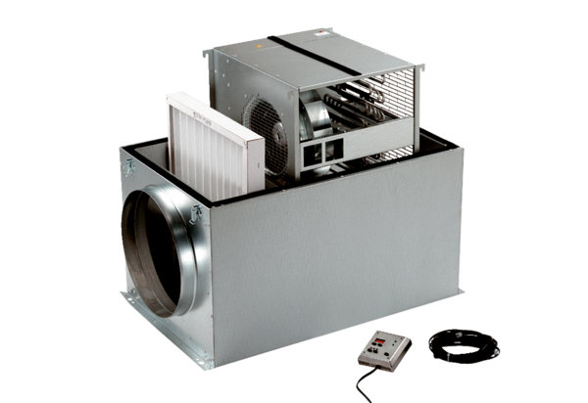Compact box ECR 31Packing unit: 1 pieceRange: C
Article number: 0080.0564Manufacturer: MAICO

