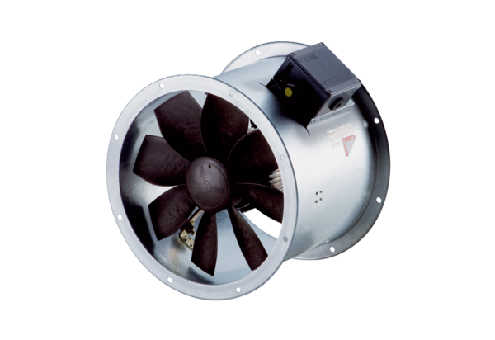Axial duct fan DZR 25/2 B Ex tPacking unit: 1 pieceRange: C
Article number: 0086.0722Manufacturer: MAICO

