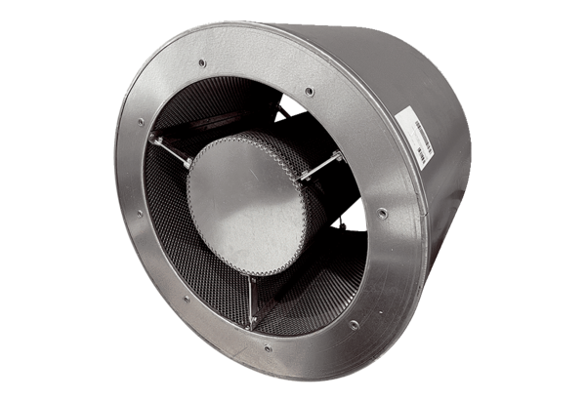Tubular sound absorber RSKI 90/1500Packing unit: 1 pieceRange: C
Article number: 0073.0119Manufacturer: MAICO

