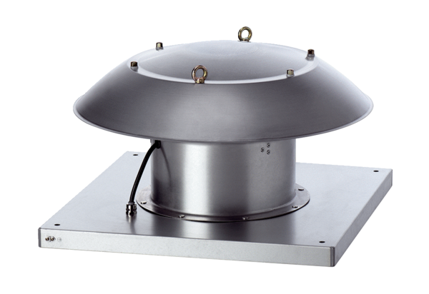Axial roof fan DZD 35/6 B Ex tPacking unit: 1 pieceRange: C
Article number: 0087.0815Manufacturer: MAICO

