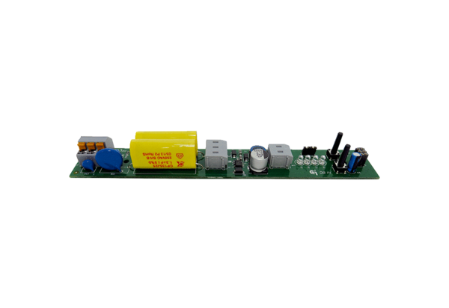Circuit board PL ECA 150 ipro VZC/H/BRange: A
Article number: E101.1411.0002Manufacturer: MAICO

