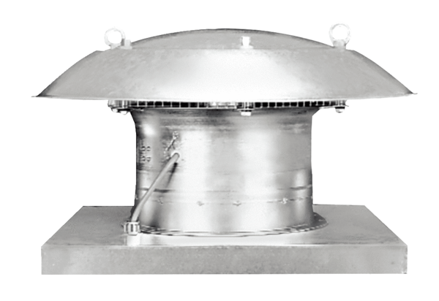Axial roof fan DZD 25/4 DPacking unit: 1 pieceRange: C
Article number: 0087.0490Manufacturer: MAICO

