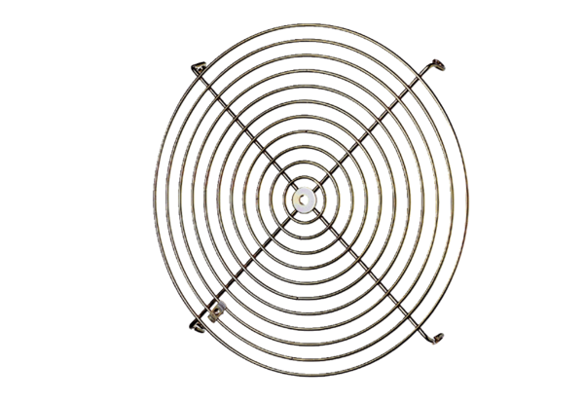Protective grille SGM 22 ExPacking unit: 1 pieceRange: C
Article number: 0150.0132Manufacturer: MAICO

