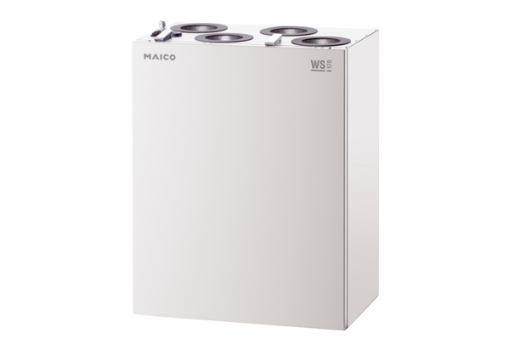Centralised ventilation unit WS 170 KRETPacking unit: 1 pieceRange: K
Article number: 0095.0112Manufacturer: MAICO

