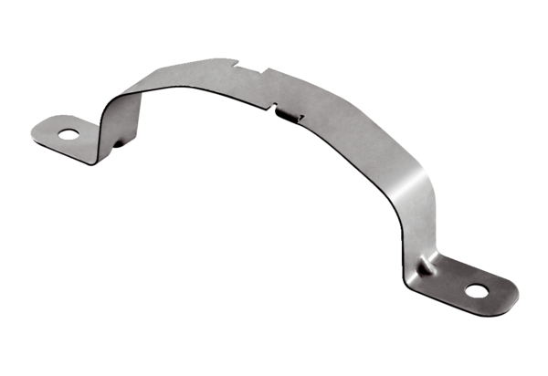Mounting clamps FFS-SPacking unit: 10 piecesRange: K
Article number: 0055.0883Manufacturer: MAICO

